UniProtKB - O49686 (PYR1_ARATH)

MPSELSPEERSELKNSIAEFHTYQLDPGSCSSLHAQRIHAPPELVWSIVRRFDKPQTYKH

FIKSCSVEQNFEMRVGCTRDVIVISGLPANTSTERIDILDDERRVTGFSIIGGEHRLTNY

KSVTTVHRFEKENRIWTVVLESYVLDMPEGNSEDDTRMFADTVVKLNLQKLATVAEGMAR

NSGDGTGSQVT

RecName: Full=Abscisic acid receptor PYR1;

AltName: Full=ABI1-binding protein 6;

AltName: Full=Protein PYRABACTIN RESISTANCE 1;

AltName: Full=Regulatory components of ABA receptor 11

Molecule type amino acid

Query Length 191

Receptor for abscisic acid (ABA) required for ABA-mediated responses such

as stomatal closure and germination inhibition.

Inhibits the activity of group-A protein phosphatases type 2C (PP2Cs)

when activated by ABA (PubMed:19407142, PubMed:19624469, PubMed:19769575,

PubMed:23844015, PubMed:21658606). Can be activated by

both (-)-ABA and (+)-ABA (PubMed:23844015).

Molecular function: Protein phosphatase inhibitor, Receptor

Biological process: Abscisic acid signaling pathway

Taxonomic identifier: 3702 [NCBI]

EXPREXION

ExpressionAtlas: O49686 baseline and differential

Genevisible: O49686 AT

DOMAIN

Upon interaction with ABA, the 'latch' and 'gate' loops change in conformation

leading to a tight dimerization and the creation a surface that enables

the receptor to dock into and inhibit the PP2C active site.

https://www.uniprot.org/uniprot/O49686

<https://www.ncbi.nlm.nih.gov/protein/O49686.1?report=genbank&log$=protalign&blast_rank=1&RID=T1WX84DT015>

1. Functie
   1. Moleculaire functie : Protein phosphatase inhibitor, receptor.

phosphatase remmende receptor.

* 1. Cellulaire locatie : 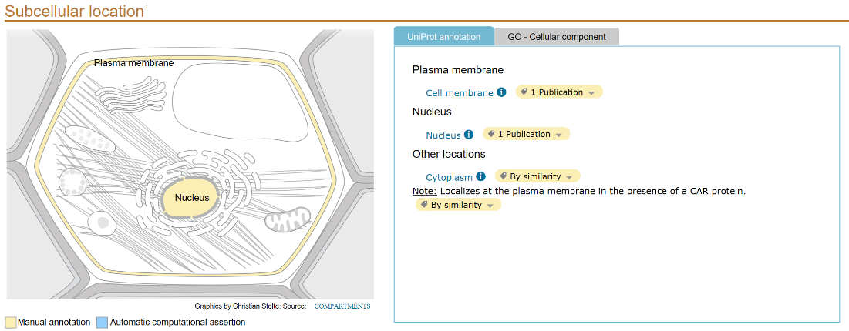
  2. Biologisch process : Abscisic acid signaling pathway.

Abscisinezuur signalerend pathway.

1. Transmembraan segmenten / topologie
2. Matches met proteïnefamilies **Interpro, Pfam :**

Polyketide cyclase/dehydrase (IPR019587)

This family contains polyketide cylcases/dehydrases which are enzymes involved in polyketide synthesis. It also includes other proteins of the START superfamily

<http://www.ebi.ac.uk/interpro/entry/IPR019587>

This family contains polyketide cylcases/dehydrases which are enzymes involved in polyketide synthesis. The family also includes proteins which are involved in the binding/transport of lipids.

<https://pfam.xfam.org/family/PF03364>

1. Geconserveerde domeinen **CDD, Prosite**

Pyrabactin resistance 1 (PYR1), PYR1-like (PYL), regulatory component of abscisic acid receptors (RCARs), and related proteins

The PYR/PYL/RCAR-like family belongs to the SRPBCC (START/RHO_alpha_C/PITP/Bet_v1/CoxG/CalC) domain superfamily of proteins that bind hydrophobic ligands. SRPBCC domains have a deep hydrophobic ligand-binding pocket. PYR/PYL/RCAR plant proteins are receptors involved in signal transduction. They bind abscisic acid (ABA) and mediate its signaling. ABA is a vital plant hormone, which regulates plant growth, development, and response to environmental stresses. Upon binding ABA, these plant proteins interact with a type 2C protein phosphatase (PP2C), such as ABI1 and ABI2, and inhibit their activity. When ABA is bound, a loop (designated the gate/CL2 loop) closes over the ligand binding pocket, resulting in the weakening of the inactive PYL dimer and facilitating type 2C protein phosphatase binding. In the ABA:PYL1:ABI1 complex, the gate blocks substrate access to the phosphatase active site. A conserved Trp from PP2C inserts into PYL to lock the receptor in a closed formation. This group also contains Methylobacterium extorquens AM1 MxaD. The mxaD gene is located within the mxaFJGIR(S)ACKLDEHB cluster which encodes proteins involved in methanol oxidation. MxaD may participate in the periplasmic electron transport chain for oxidation of methanol. Mutants lacking MxaD exhibit a reduced growth on methanol, and a lower rate of respiration with methanol.

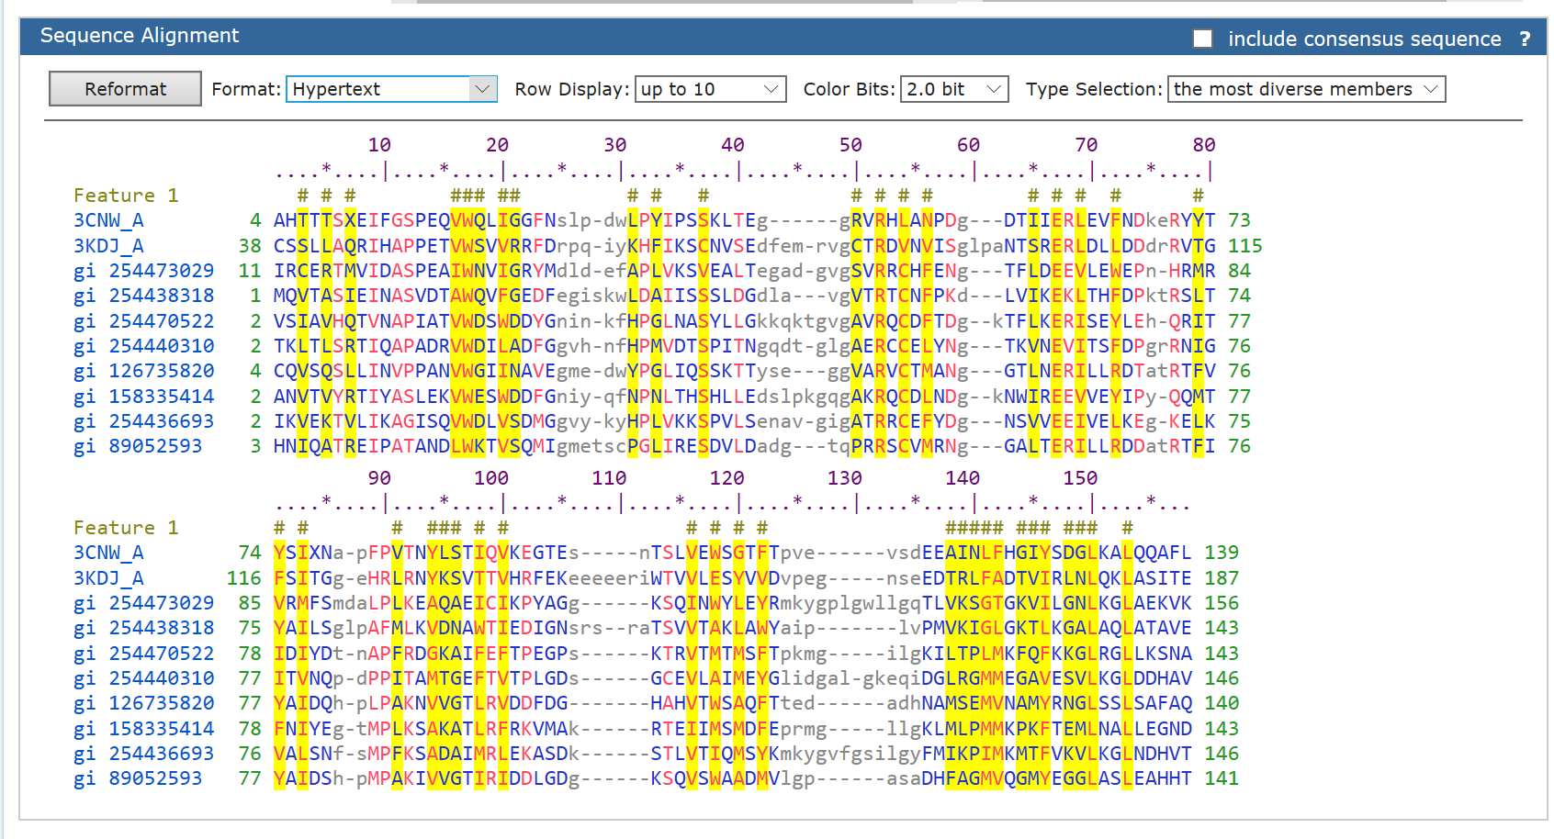

<https://www.ncbi.nlm.nih.gov/Structure/cdd/cddsrv.cgi?uid=176863>

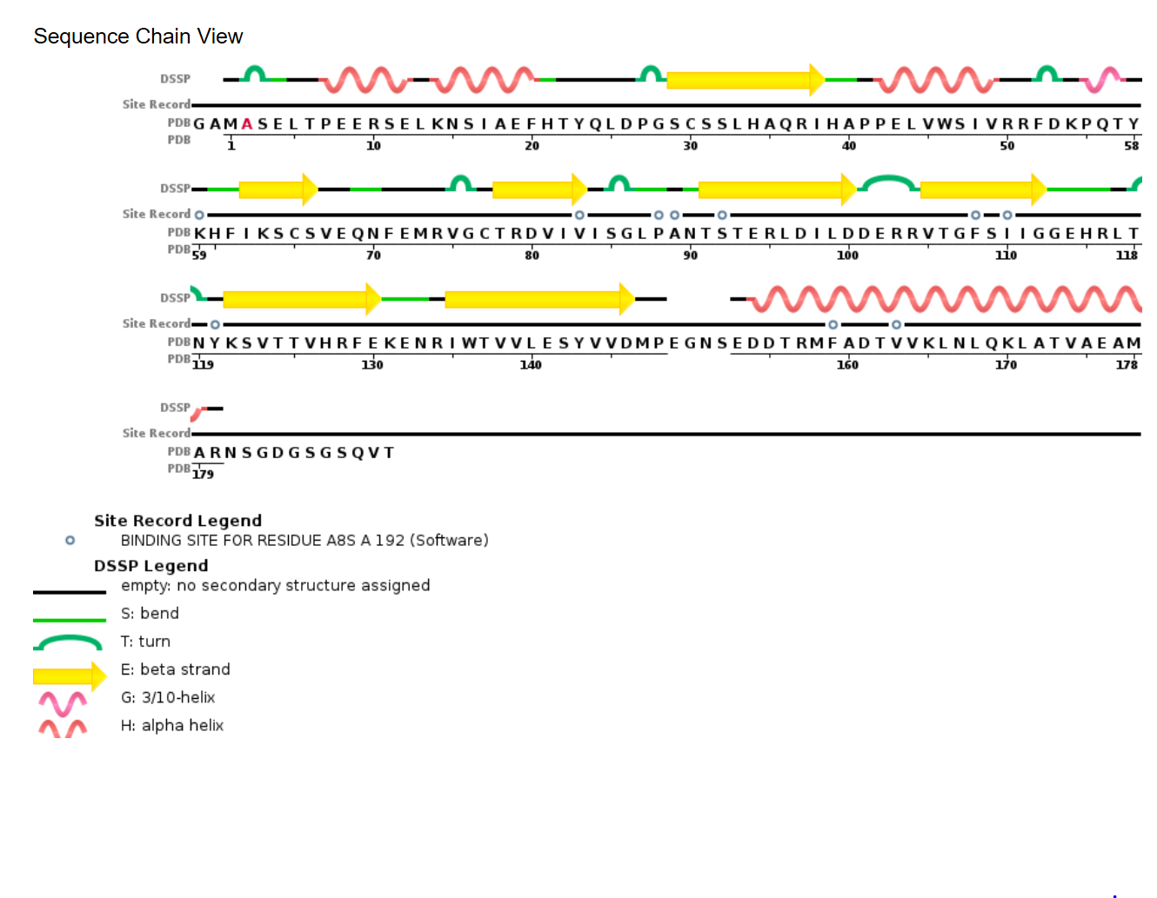

<http://www.rcsb.org/pdb/explore/remediatedSequence.do?structureId=3K90>

1. Profiles **MOTIF search**